**CMSC495 – Project Analysis – 04/06/2014**

**Team C – Jamie Lane, Bradley Norman, Daniel Ross**

**A. Identify all outside systems with which this system interfaces.**

User, IP Network (LAN, WAN), Open Arena Server

**B. Identify all input data and the source(s) of these input data.**

User → source IP address, destination IP address, destination port, build directive, transmit directive

Open Arena Server → status response packet

**C. Identify all output data and the destinations of these data.**

Status request packet → Open Arena Server

Packet size ratio of sent/received packets → User

**D. Identify the data processing function of this system:**

This system receives source IP address, destination IP address, and destination port input from the user via a GUI. Then it constructs UDP packets and IP packet headers; combines IP packet headers and UDP packet payloads; calculates complete packet size; transmits packets to the Open Arena server at the destination address upon user initiation; receives packets from the Open Arena server; calculates size of received packets; and calculates the ratio of the sent/received packet sizes to be output to the GUI. Figure 1 contains a System Context Diagram depicting data flowing in and out of the system under analysis.

**E. Based on the data processing steps, break the system into sub-systems, each dedicated to a single task (specify the task that each subsystem does). These subsystems together show the data processing function that converts the input data into output data.**

User – determines the source and destination IP addresses and the destination port

Input Subsystem (GUI) – records the source and destination IP addresses and the destination port

Builder (GUI) – starts packet constructors and combiner, stores resulting packet

UDP Packet Constructor – constructs UDP packet

IP Header Constructor – constructs the IP packet header

IP/UDP Combiner – combines IP header with UDP packet to generate Status Request packet

Packet Size Calculator – calculates the total size of a packet

Outbound – interfaces with Host OS to allow packet transmission

Transmitter (GUI) – sends status request packet to Outbound

Inbound – interfaces with Host OS to allow packet receipt

Receiver – receives Status Response packet from Inbound, stores it

Ratio Calculator – calculates packet size ratio of sent/received packets

Display Subsystem (GUI)

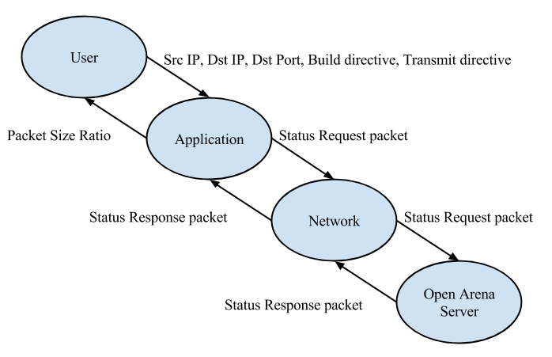

*Figure 1.* System Context Diagram. Each oval represents a system. Each arrow represents a data pathway.

**F. Identify interface data between each subsystem (and which subsystem processes the inputs, which subsystem does the output).**

User → Input Subsystem

User → Builder

User → Transmitter

Input Subsystem → Builder, Transmitter

Builder → UDP Packet Constructor, IP Header Constructor, IP/UDP Combiner

IP/UDP Combiner → Transmitter, Packet Size Calculator

Transmitter → Outbound

Inbound → Receiver

Receiver → Packet Size Calculator

Packet Size Calculator → Ratio Calculator

Ratio Calculator → Display Subsystem

Display Subsystem → User

**G. Check the solution against the requirements.**

|  |  |
| --- | --- |
| Requirement | Description |
| 1 | nonfunctional requirement |
| 2 | nonfunctional requirement |
| 3 | Input Subsystem (GUI) |
| 4 | nonfunctional requirement |
| 5 | Input Subsystem (GUI) |
| 6 | Input Subsystem (GUI) |
| 7 | Input Subsystem (GUI) |
| 8 | UDP Packet Constructor |
| 9 | IP Header Constructor |
| 10 | Builder (GUI), IP/UDP Combiner |
| 11 | Packet Size Calculator |
| 12 | Transmitter (GUI), Outbound |
| 13 | Inbound, Receiver |
| 14 | Packet Size Calculator |
| 15 | Ratio Calculator |
| 16 | Display Subsystem (GUI) |
| 17 | nonfunctional requirement |
| 18 | nonfunctional requirement |
| 19 | nonfunctional requirement |

**H. Identify risks in your design and possible ways for mitigating these risks .**

A risk associated with testing or using this application is the possibility of causing a Denial-Of-Service “attack” on the host machine when using the host IP address as the source IP address. This risk will be mitigated by the application sending a single packet per user click. It is highly unlikely that a user would inadvertently generate enough clicks to compromise their own system or network.

An additional testing risk, would be the possibility of impacting the performance of an Open Arena server without the administrator’s permission. This risk will be mitigated by only testing with a server hosted by a member of the development team.

The application will be designed to provide proof of a vulnerability, while minimizing the risk of it becoming an actual malware or hacking tool. One mitigating factor is that the patches for the vulnerability the application exploits became available in 2010. The remaining mitigating techniques will be applied during the application design phase. It will not be designed to be operated remotely. Its design will not include operation by a timer. The interface will not have hidden functionality. The code will not include deliberately opaque or obfuscated functionality.

**I. Identify possible enhancements (new features) to your design; this is a way to get future work.**

Add the ability to add multiple destination IP addresses to demonstrate a Distributed Denial-of-Service attack.

Add the ability to exploit additional Open Arena server vulnerabilities.

Add the ability for the user to specify a custom UDP payload. With small modifications, the application could be used to demonstrate similar vulnerabilities in other servers.